Objectives:

* Using float
* Using the Round function
* **There are 5 challenge exercises, each worth 20%**

Please submit this document for grading when completed… Please work in groups.

1. The float returns a floating-point number from a number to a string. Float allows decimal points to be entered.

Sample output

1. Getting the remainder operator

Sample output

1. Delete the extra / and run the program again, notice that the results give us a fractional output.

1. Getting the future value

Sample output

1. **Challenge** **Exercise** **#1**: modify #4 (the future value program) so it does NOT display any fractional output.

**#1 print screen the code with the output below here.**

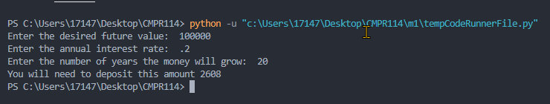

Code:

future_value = float(input("Enter the desired future value: "))

rate = float(input("Enter the annual interest rate: "))

years = int(input("Enter the number of years the money will grow: "))

present_value = future_value / (1.0 + rate) ** years

print("You will need to deposit this amount", int(present_value))

1. Rounding floating point numbers.

Sample output

1. **Challenge** **Exercise** **#2:** Turn to page 114 and complete the Sales Prediction program

**#2 print screen the code with the output below here.**

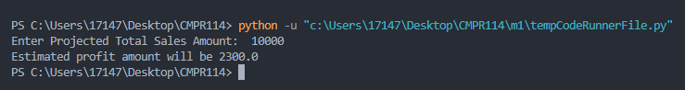

Code:

totalsales = float(input("Enter Projected Total Sales Amount: "))

profitpct = .23

profit = totalsales * profitpct

print("Estimated profit amount will be", profit)

1. **Challenge** **Exercise** **#3:** Turn to page 115 and complete the Tip, Tax and Total program

**#3 print screen the code with the output below here.**

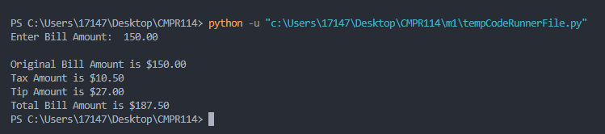

Code:

billamt = float(input("Enter Bill Amount: "))

taxamt = billamt * .07

tip = billamt * .18

totalbill = billamt + taxamt + tip

print("\nOriginal Bill Amount is ${:,.2f}".format(billamt))

print("Tax Amount is ${:,.2f}".format(taxamt))

print("Tip Amount is ${:,.2f}".format(tip))

print("Total Bill Amount is ${:,.2f}".format(totalbill))

1. **Challenge** **Exercise** **#4:** Turn to page 115 and complete the Male and Female Percentages program.

**#4 print screen the code with the output below here.**

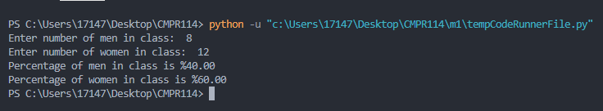

Code:

mencnt = float(input("Enter number of men in class: "))

womencnt = float(input("Enter number of women in class: "))

total = mencnt + womencnt

menpct = (mencnt / total) * 100

womenpct = (womencnt / total) * 100

print("Percentage of men in class is %{:,.2f}".format(menpct))

print("Percentage of women in class is %{:,.2f}".format(womenpct))

1. **Challenge** **Exercise** **#5:** The Stock Transaction program.

Write a program that will print the amount of money paid for the stock, the amount paid to the broker, and the amount profited from the sales of the stock.

The number of shares is 2000

The Per Share price when purchased is 40.00

Commission to the broker is 3%

The Per Share price when sold is 42.75

Sample output

**#5 print screen the code with the output below here.**

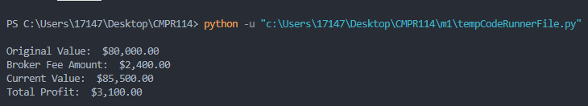

Code:

sharesheld = 2000

purchase_shareprice = 40.00

sold_shareprice = 42.75

commpct = .03

origvalue = sharesheld * purchase_shareprice

currvalue = sharesheld * sold_shareprice

commission = origvalue * commpct

profit = currvalue - origvalue - commission

print("\nOriginal Value: ${:,.2f}".format(origvalue))

print("Broker Fee Amount: ${:,.2f}".format(commission))

print("Current Value: ${:,.2f}".format(currvalue))

print("Total Profit: ${:,.2f}".format(profit) + "\n")

**Submit this document to Module 1 Class Exercise**